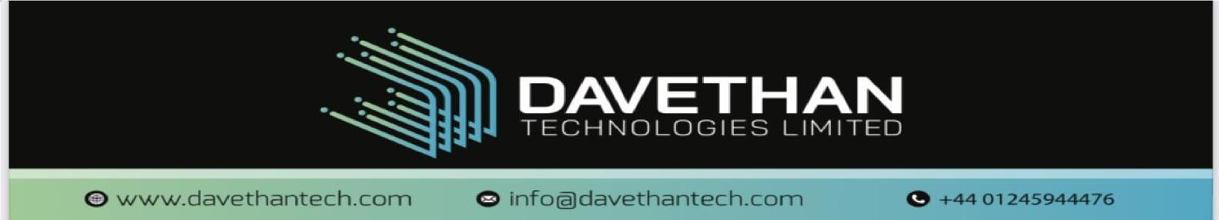
L.O.F Website Requirement Questionnaire
Client: Layeni Ogunmakinwa Foundation (L.O.F)
Purpose: To gather all necessary information to design, develop, and launch the organization’s website.

A. General Information
- Organization Full Name:: Layeni Ogunmakinwa Foundation
- Preferred Short Name/Acronym (if any): LOF
- Primary Contact Person:
  - Name: Otunba Olumide Ogunmakinwa
  - Role: Executive Director / CEO
  - Email: attabboy@hotmail.com
  - Phone: +13017687791
- Secondary Contact Person (if any):
  - Name: Pastor Ajibola Ogunmakinwa
  - Role: Director
  - Email: drdungus@yahoo.com
  - Phone: +2348033527971
- Organization Address (physical location): 2925 Winterbourne Dr., Upper Marlboro, Maryland, 20774, USA
- Countries of Operation: USA and Nigeria
- Target Audience (tick all that apply): (✔)
  - Individual Donors
  - Corporate Partners
  - NGOs/Foundations
  - Volunteers
  - Government/Institutions
  - General Public
  - Others (please specify):

B. Brand Identity & Design
- Do you already have a brand identity? (✔)
  - Yes
  - No
If yes, please provide:
- Logo (attach file)

- Brand Colors:
- Fonts (if any):
- Brand Guidelines (if available):
- If no, do you want the team to design a logo/brand kit? (✔)
  - Yes
  - No
- Preferred Website Style: (✔)
- More images / visual storytelling
- More text / information-focused
- Balanced mix
- Open to designer’s recommendation
- Any websites you admire and would like your site to resemble? (Please list links)

C. Website Structure & Content
- Confirm preferred pages (tick all that apply): (✔)
- Home
- About Us
- Initiatives/Projects
- Impact
- Blog/News
- Contact Us
- Careers
- FAQ
- Privacy Policy
- Other (please specify): _______________________
- About Us Section – Please provide:
- Mission: SEE ATTACHED
- Vision: SEE ATTACHED
- Core Values: SEE ATTACHED
- History of the organization: SEE ATTACHED
- Initiatives/Projects Section:
- Do you want categories for:
  - Ongoing projects
  - Past projects
  - Upcoming projects
- Please list key initiatives you want featured:
- See attached documents
- Impact Section:
Please provide (if available):
- Number of lives impacted:
- Number of students educated: 38 and counting
- Communities reached: Akure and its environs, Ile - Oluji
- Any success stories or testimonials: T.B.D
- Do you want a Blog/News section? (✔)
- Yes
- No
If yes, who will manage it?
- Internal team via CMS
- Website team initially

D. Donations & Engagement Features
- Donate Now Button:
- Should donations be processed via:
  - Bank transfer
  - Payment gateway (e.g., Paystack, Flutterwave, Stripe)
  - Both
- If payment gateway, please specify preferred provider: _____
- Volunteer Feature:
- Should “Become a Volunteer” link lead to:
  - Contact form
  - Dedicated volunteer form
  - External link (please provide): https://forms.gle/grCpF9MYnAo4NZfT7
- Contact Form:
What email should receive messages from the website?
lof.us.ng@gmail.com
- Do you want newsletter sign-up on the website? (✔)
- Yes
- No
If yes, preferred tool (e.g., Mailchimp): _________

E. Social Media & Digital Presence
- Existing Social Media Accounts (provide links):
- Facebook:
- Instagram: Instagram
- LinkedIn:
- YouTube: Layeni Ogunmakinwa Foundation - YouTube
- X (Twitter):
- Do you want social media icons displayed in the website footer? (✔)
- Yes
- No
- Do you plan to share video content/testimonials on the website? (✔)
- Yes
- No

F. Technical Requirements
- Do you already have a domain name? (e.g., www.lof.org)
- Yes → Please provide: ____________
- No → Do you want the team to help purchase one? Yes
- Do you want a Content Management System (CMS) to update the site yourself? (✔)
- Yes
- No
- Who will manage website updates after launch?
- Foundation’s Internal team
- Development team (maintenance package)

G. Timeline & Budget
- Preferred launch date: April 2026
- Which package are you considering? (✔)
- N550 package
- N900 package
- Any additional features you want (e.g., events calendar, live streaming, donation tracker)? _________________

H. Assets to Provide
Please share the following if available:
- High-quality images of programs TO BE UPLOADED LATER
- Videos of outreach activities TO BE UPLOADED LATER
- Organizational profile/brochure
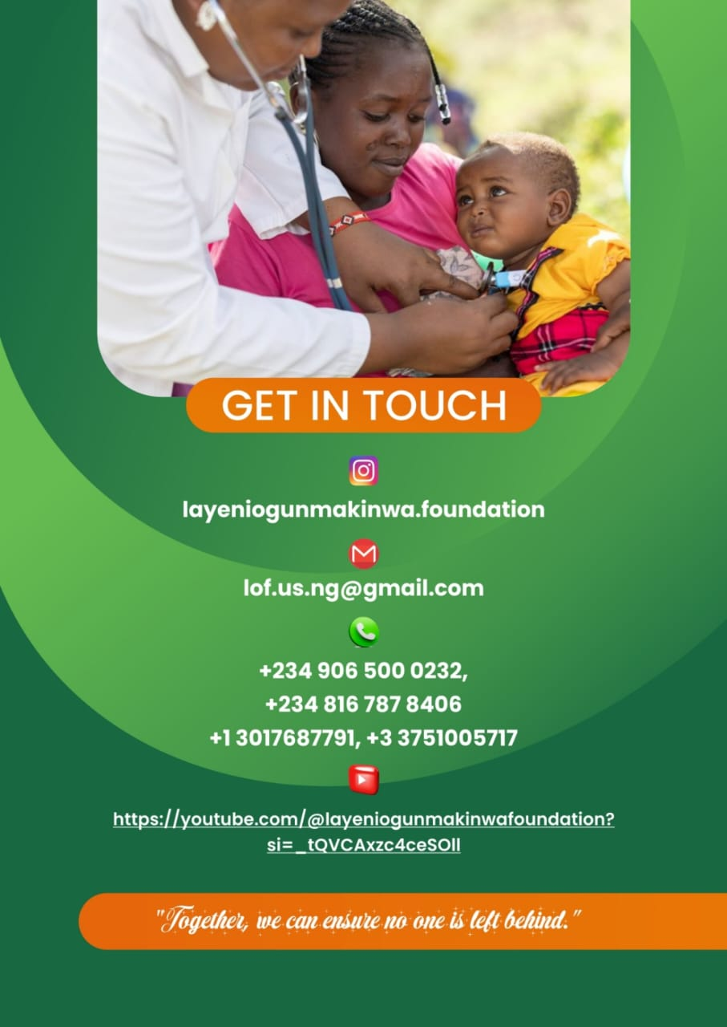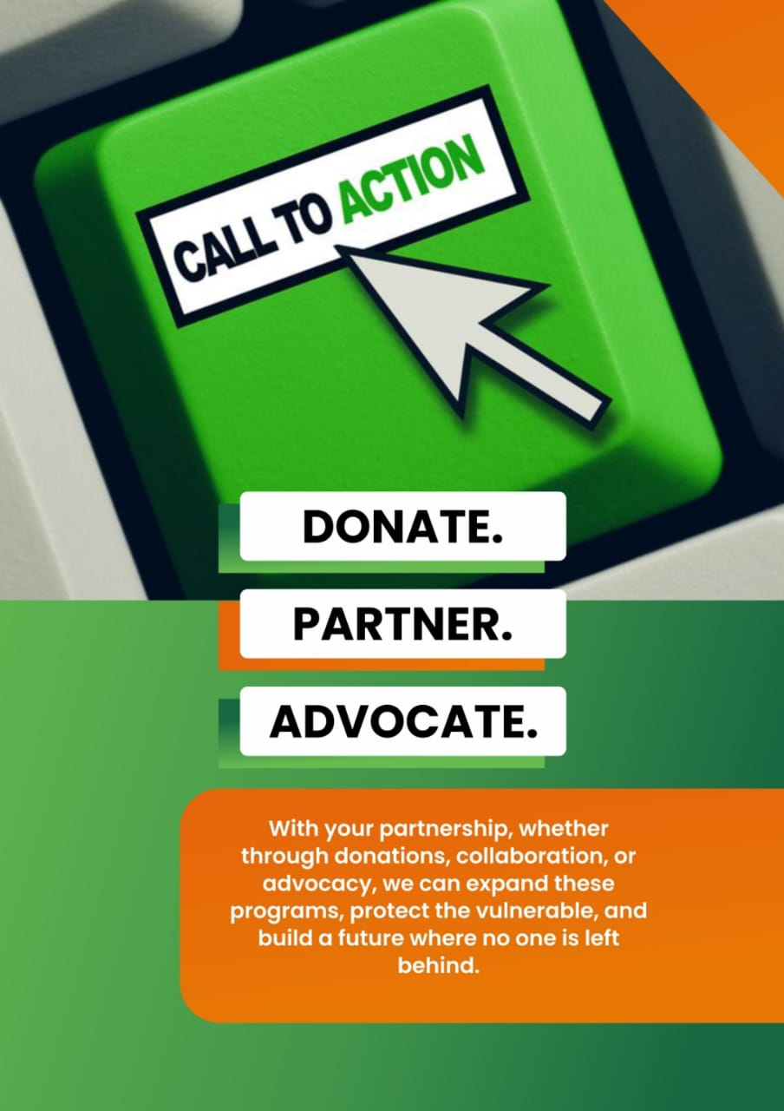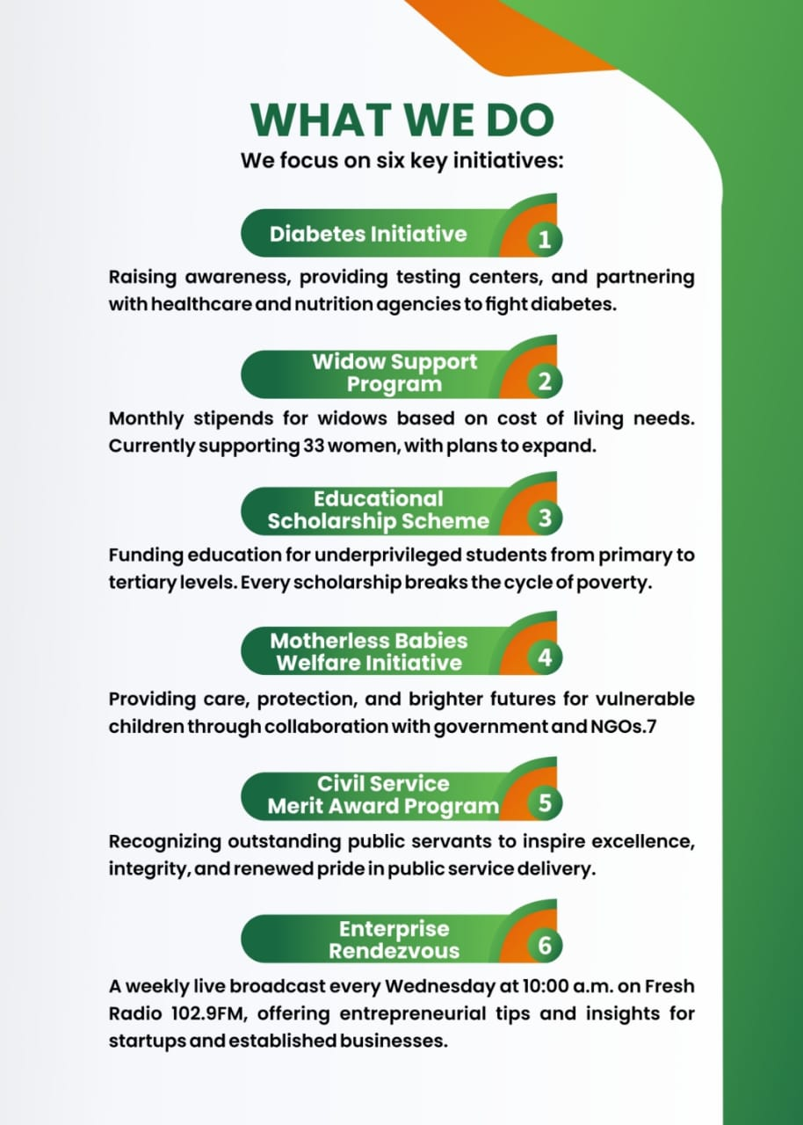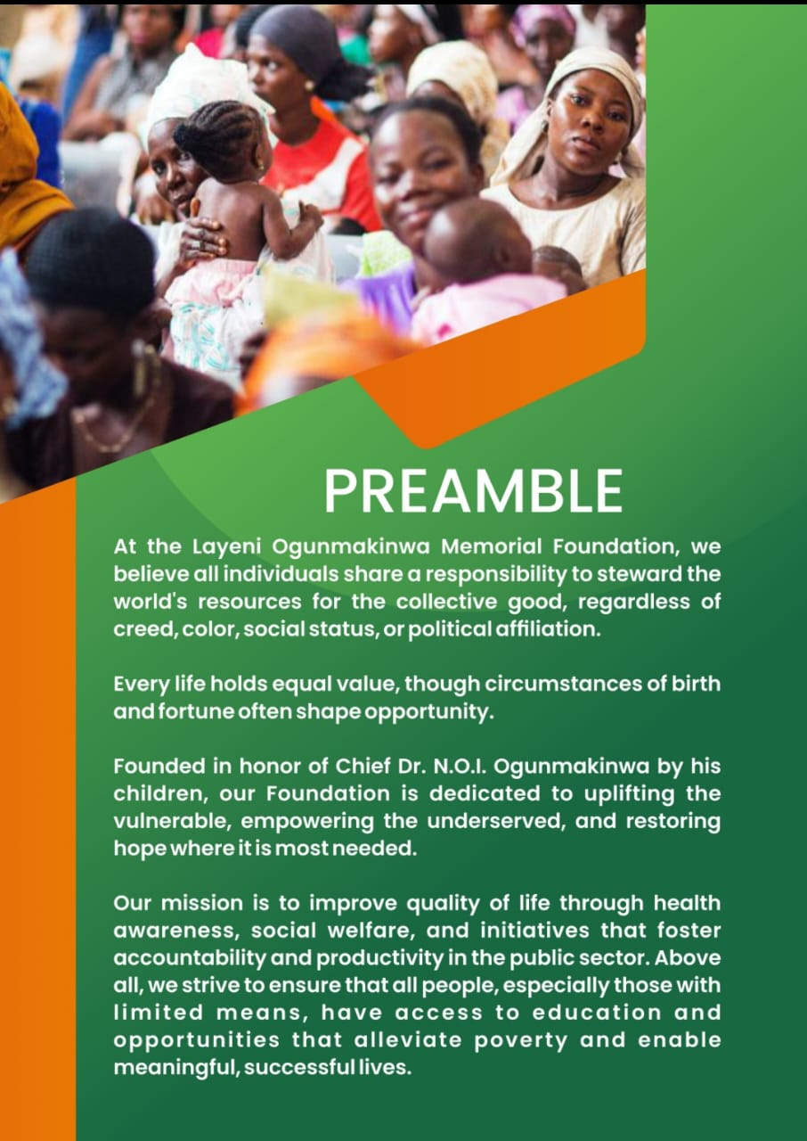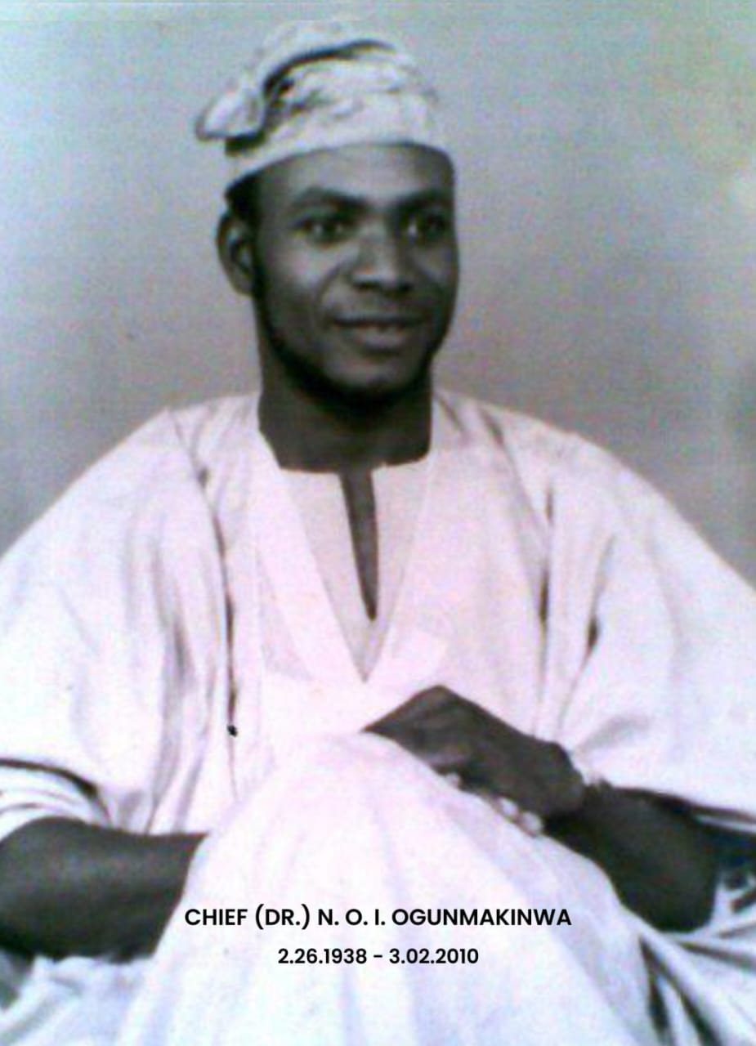
- Team photos and bios
LOF Documents
- Past impact reports

I. Final Notes
- Any other requirements or expectations for the website? None for now

Submitted by: Olumide B. Ogunmakinwa Date: February 18, 2026

